# Assignment Title:

Coursework

# Coursework Type:

Individual

# Module Name:

ST4005CEM Database System

**Intake:** September

# Submitted By:

CU ID:14812055

College ID: 230342 Name:Shreesha Shrestha

# Submitted to:

Name :Ayush Kaji Dangol



**Table of Contents**

Introduction 5

Un-Normalized Form 7

Normalization 8

First Normal Form (1 NF) 9

Second Normal Form (2 NF) 10

Third Normal Form (3 NF) 11

Entity Relationship Diagram (ERD) 12

SQL Queries 13

Data Visualization 26

Conclusion 32

Reference 33

# Table of figure

# Figure 1 5

# Figure 2: 6

# Figure 3: 7

# Figure 4: 8

# Figure 5: 9

# Figure 6: 10

# Figure 7: 11

# Figure 8: 12

# Figure 9: 13

# Figure 10: 14

# Figure 11: 15

# Figure 12: 16

# Figure 13: 17

# Figure 14: 18

# Figure 15: 19

# Figure 16: 20

# Figure 17 21

# Figure 18: 21

# Figure 19: 22

# Figure 20: 22

# Figure 21: 23

# Figure 22: 23

# Figure 23: 24

# Figure 24: 24

# Figure 25: 25

# Figure 26: 26

# Figure 27: 27

# Figure 28: 28

# Figure 29: 29

# Figure 30: 30

# Introduction

A database, in the most general sense, is an organized collection of data. More specifically, a database is an electronic system that allows data to be easily accessed, manipulated and updated.

In other words, a database is used by an organization as an electronic way to store, manage and retrieve information. The database is one of the cornerstones of enterprise IT, and its ability to organize, process and manage information in a structured and controlled manner is the key to many aspects of modern business efficiency.

However, databases go way beyond simply storing data. As we’ll see later, the inherent logic and

efficiency in how the data is stored and retrieved can provide an incredibly powerful business tool to an organization. This is especially true when databases are properly exploited for their reporting and business intelligence capabilities.(Sivanes, 2022b)

# Figure 1

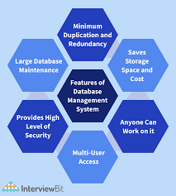

# Un-Normalized Form

In this un-normalized form, When a structure satisfies all the properties of a relation except for the first item.Some of the entries contain repeating groups and thus are not single-valued.

# Figure 2:

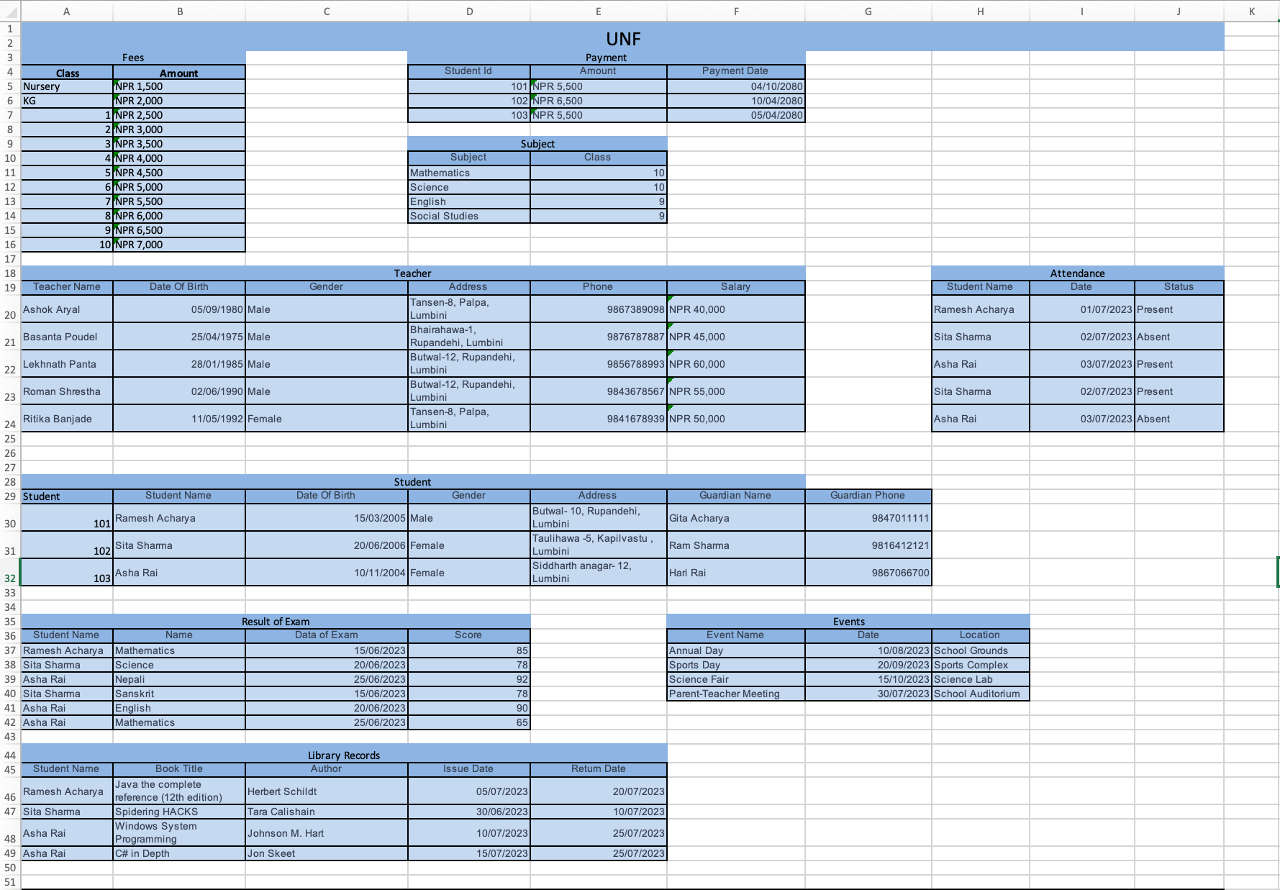

# Normalization

Normalization is the process of minimizing redundancy from a relation or set of relations. Redundancy in relation may cause insertion, deletion, and update anomalies. So, it helps to minimize the redundancy in relations. Normal forms are used to eliminate or reduce redundancy in database tables.

# Figure 3:

*Types of Normal Forms*

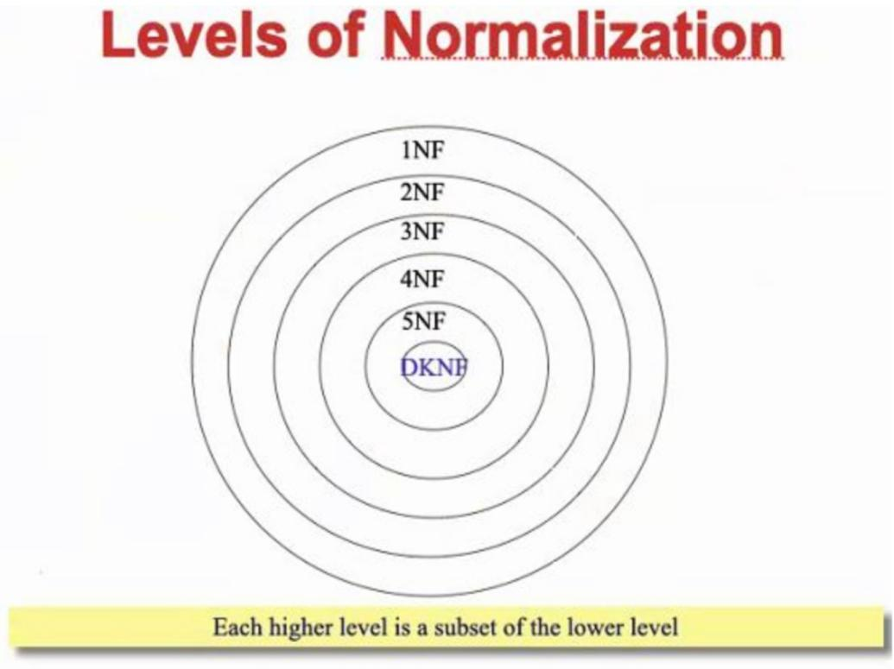

The normal forms covered in our course are:

1. First Normal Form (1NF)
2. Second Normal Form (2NF)
3. Third Normal Form (3NF)

# First Normal Form (1 NF)

First Normal Form (1NF) is defined as a table that has a primary key, where no single column contains multiple values, and the non-primary key columns are dependent on the primary key. If a table does not consists multivalued attributes, it is in first normal form.

# Figure 4:

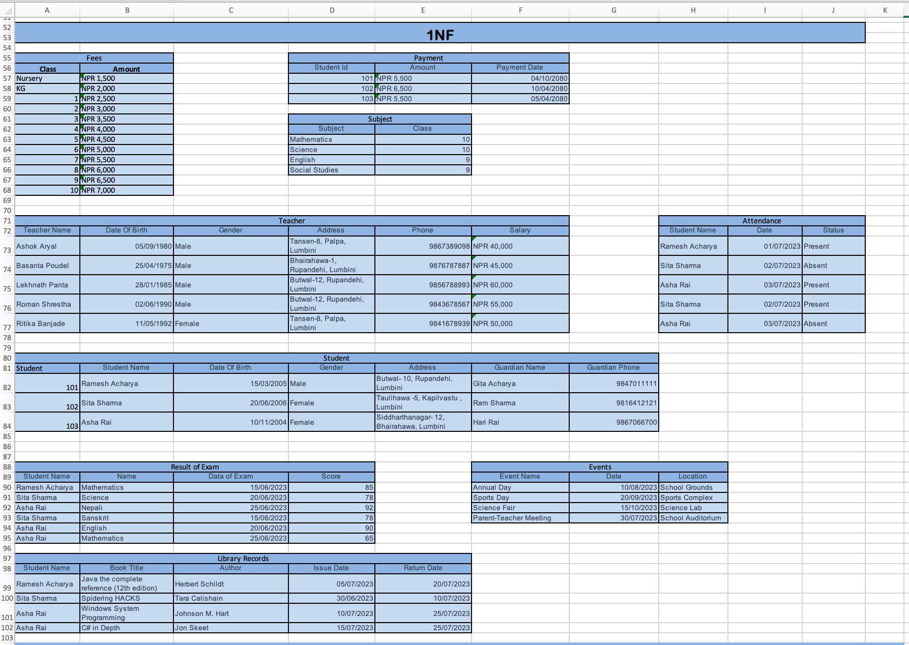

# Second Normal Form (2 NF)

In 2NF, the relation present should be 1NF, and no partial dependency should exist. Partial dependency is when the non-prime attributes depend entirely on the candidate or primary key, even if the primary key is composite. If every non-key attribute in table is only dependent on primary key, then the tables are in second normal form.

# Figure 5:

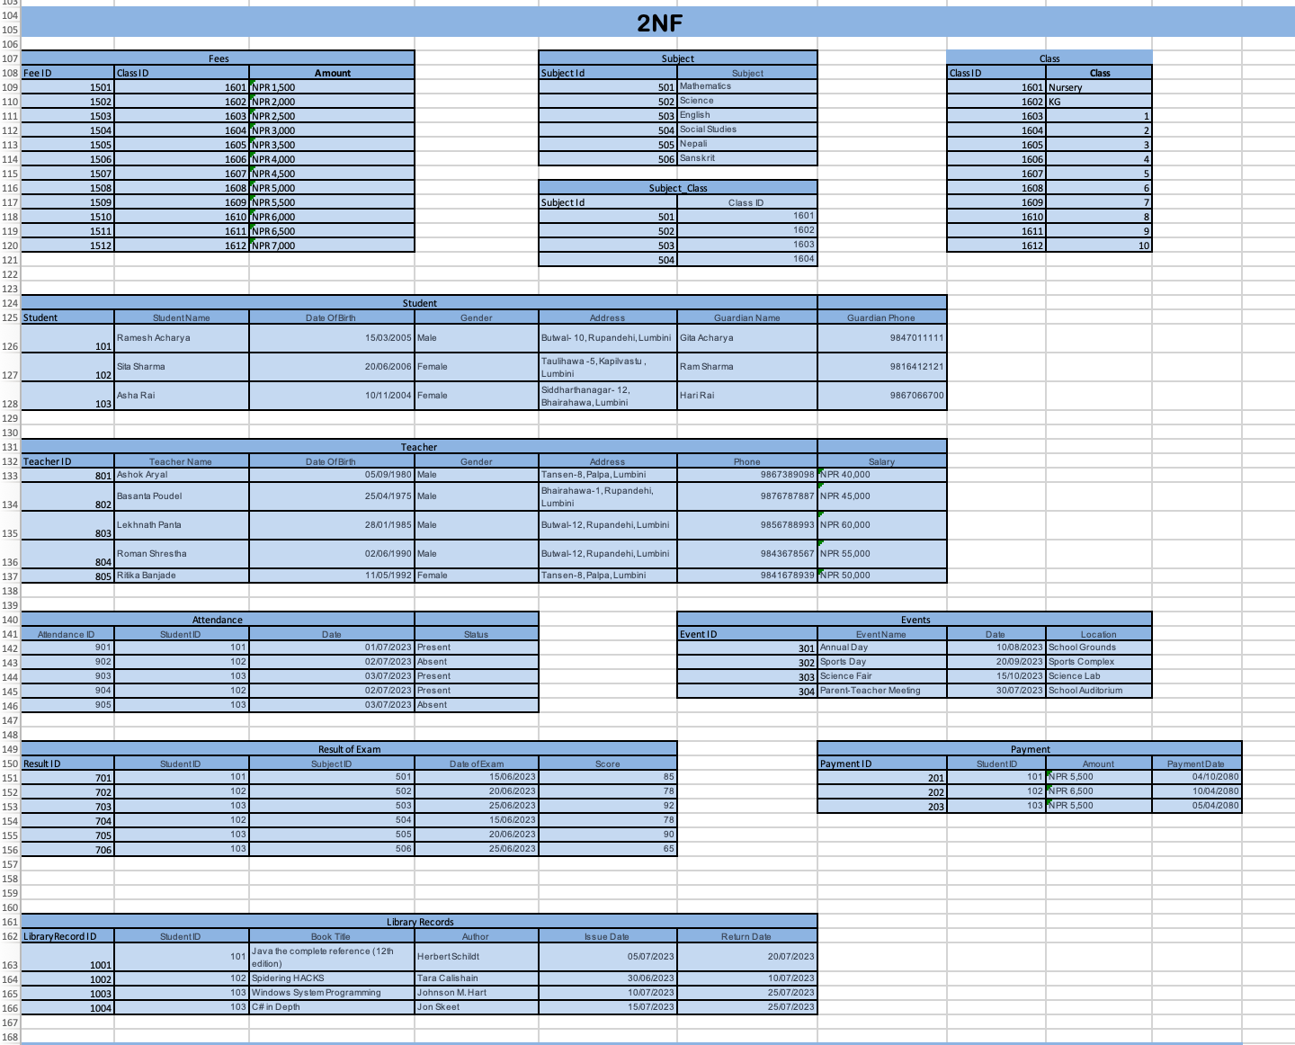

# Third Normal Form (3 NF)

In 3NF, the given relation should be 2NF, and no transitivity dependency should exist, i.e., non- prime attributes should not determine non-prime attributes.When all non-key attributes do not have any inter-dependencies among non-key attributes only, it is called third normal form.

# Figure 6:

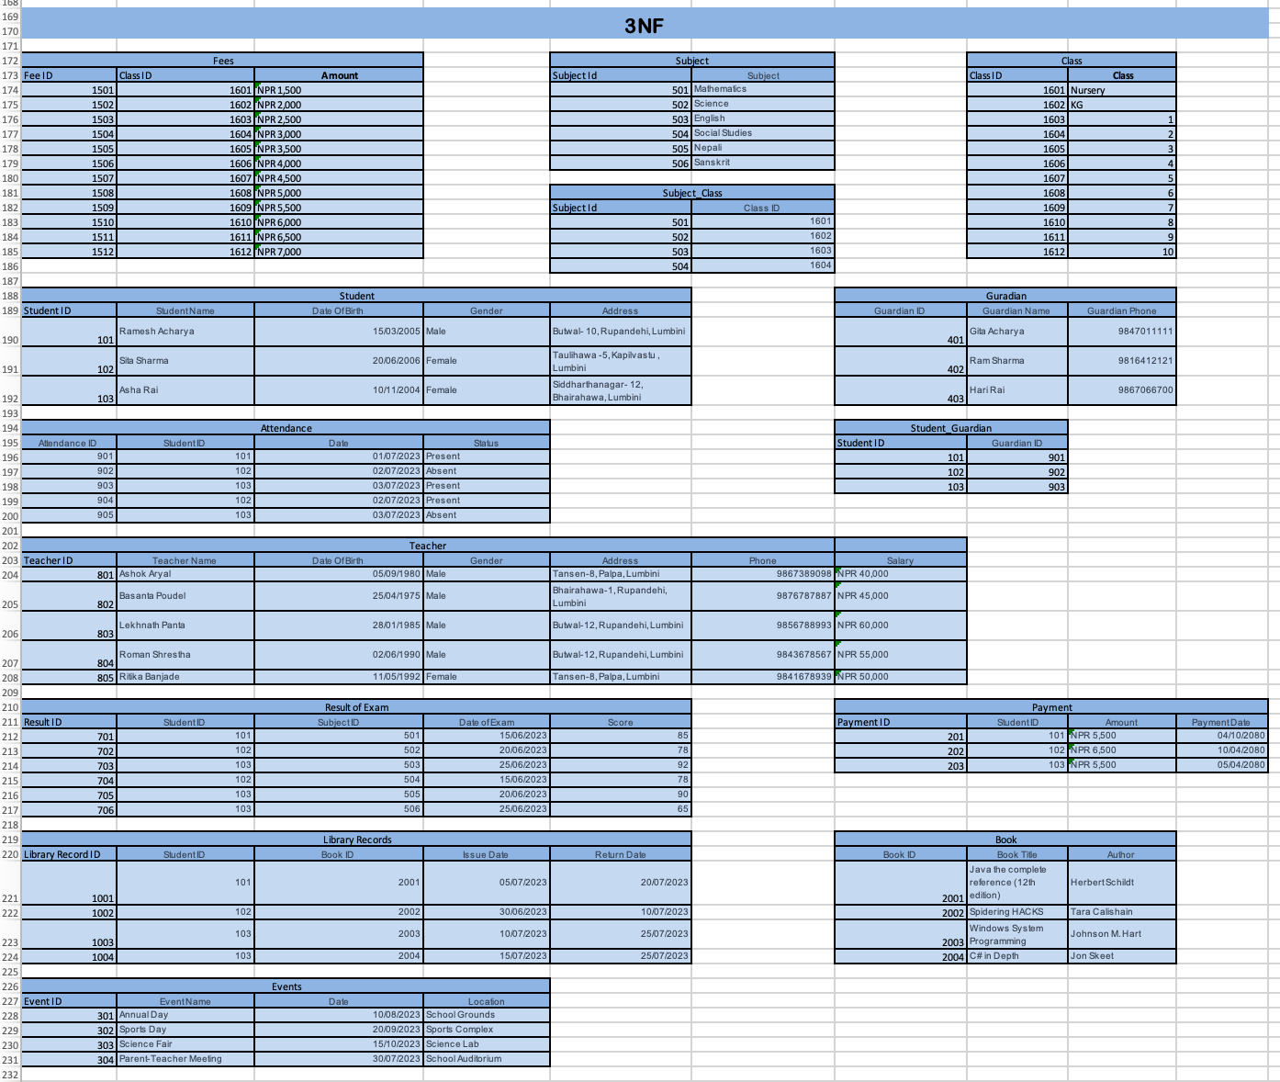

# Entity Relationship Diagram (ERD)

An Entity Relationship (ER) Diagram is a type of flowchart that illustrates how “entities” such as

people, objects or concepts relate to each other within a system. ER Diagrams are most often used to design or debug relational databases in the fields of software engineering, business information systems, education and research. Also known as ERDs or ER Models, they use a defined set of symbols such as rectangles, diamonds, ovals and connecting lines to depict the interconnectedness of entities, relationships and their attributes.

# Figure 7:

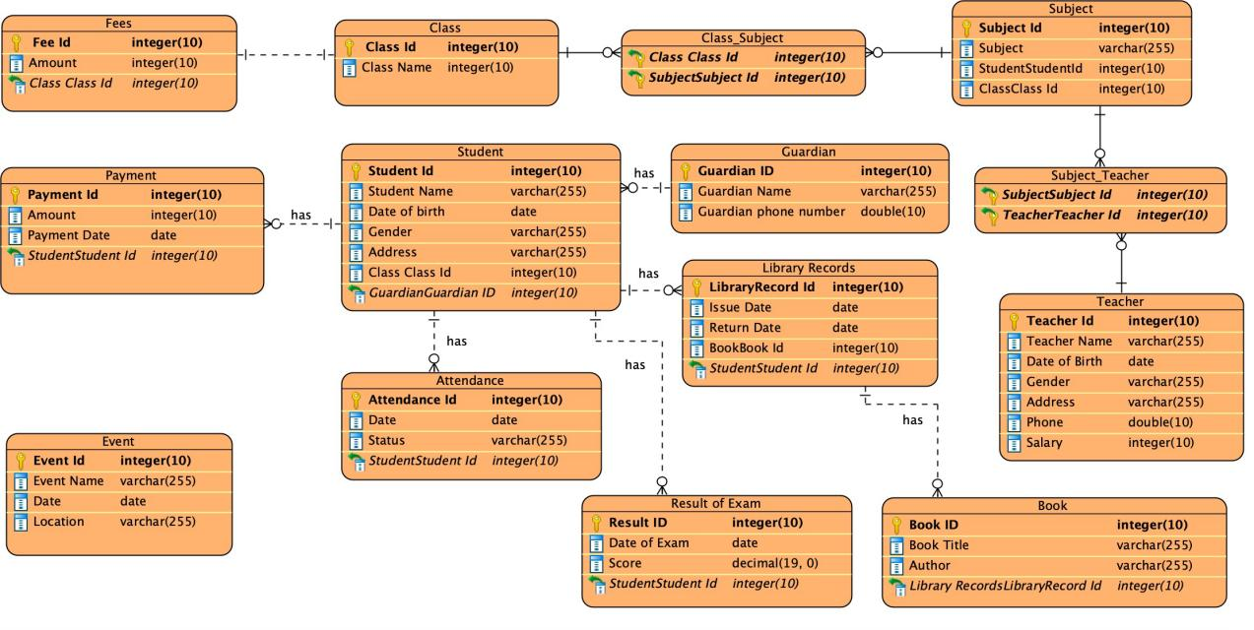

# SQL Queries

A SQL query is an expression, similar to an English sentence, that defines the set of data to be retrieved from the database. You can think of a SQL query as a question you sent to the database; after that, you expect the database will respond to the question by sending back the data.

**Figure 8:**

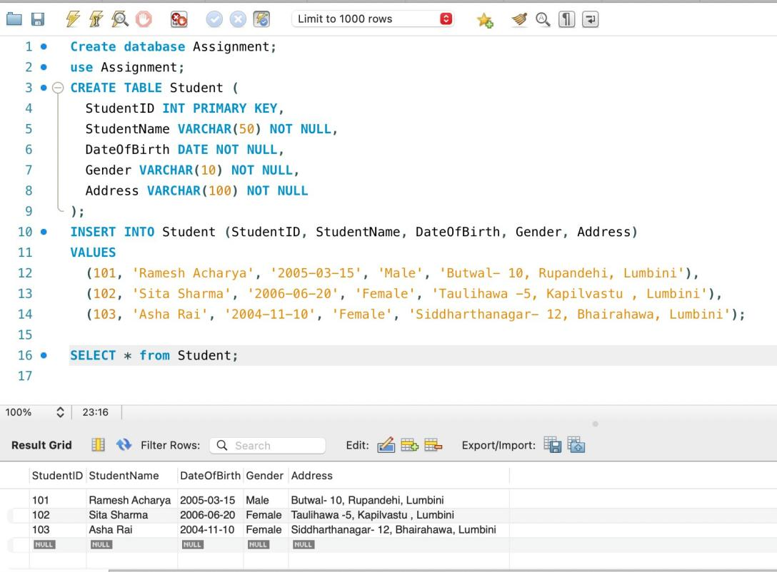

**Figure 9:**

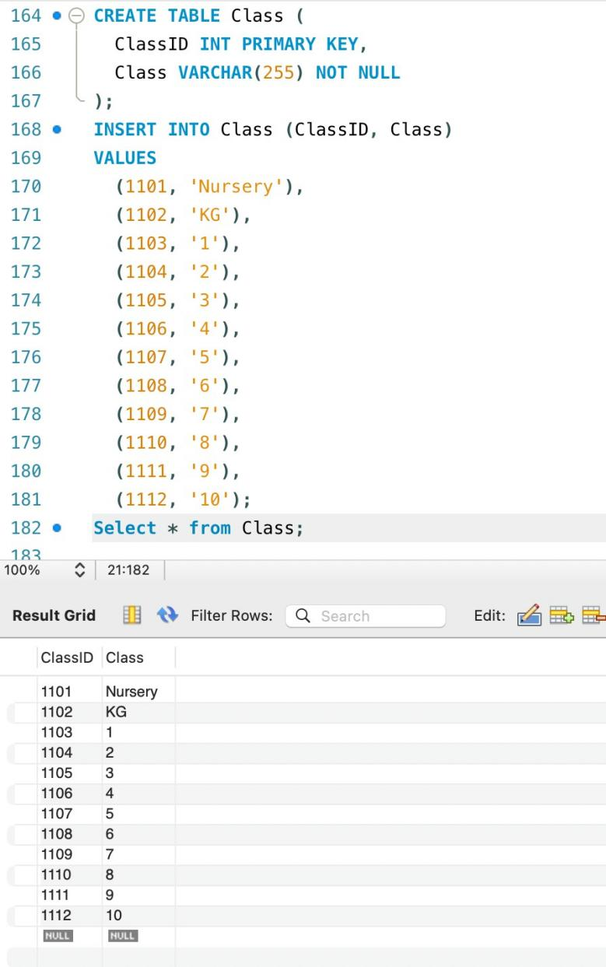

**Figure 10:**

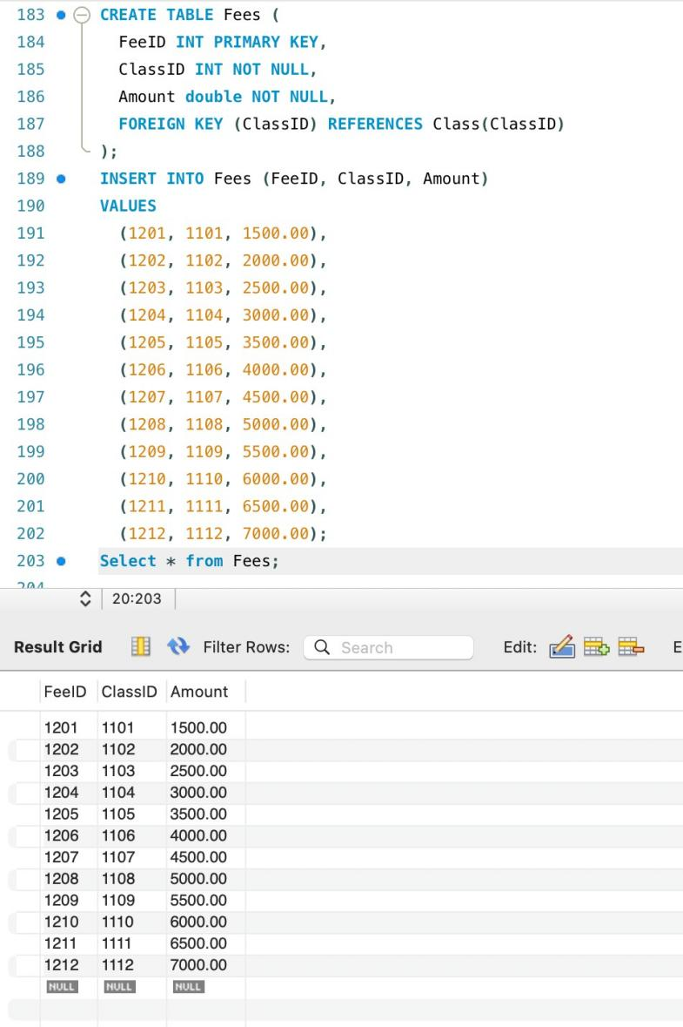

**Figure 11:**

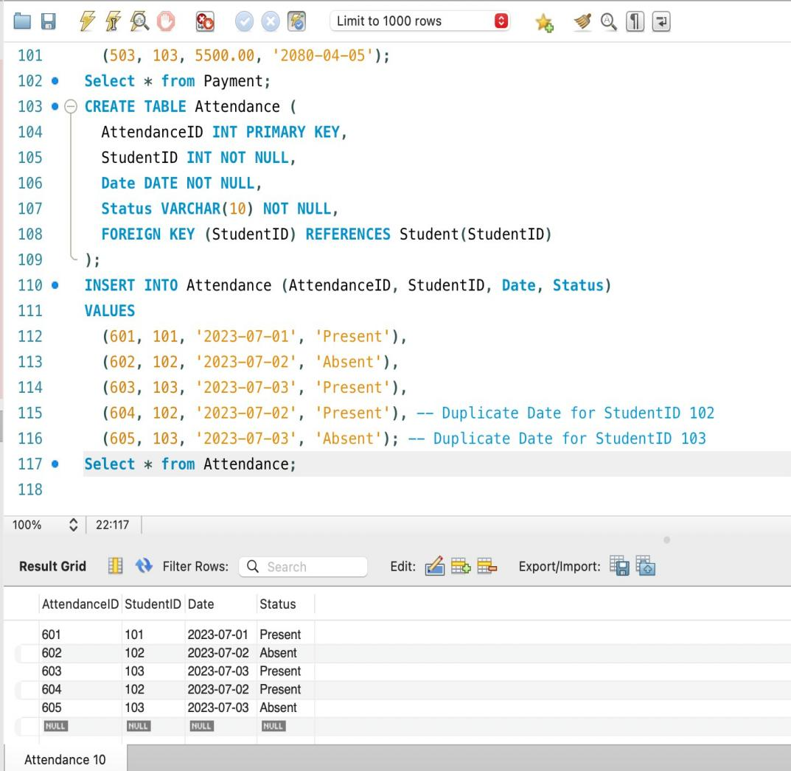

**Figure 12:**

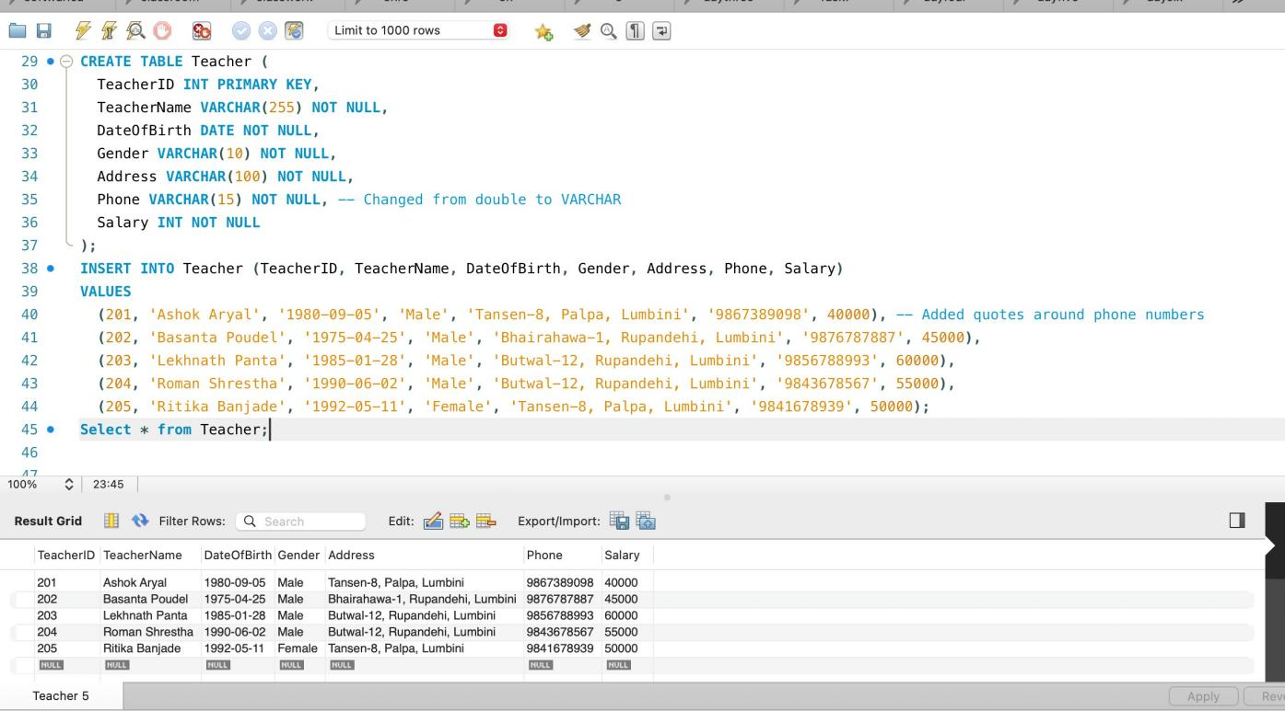

**Figure 13:**

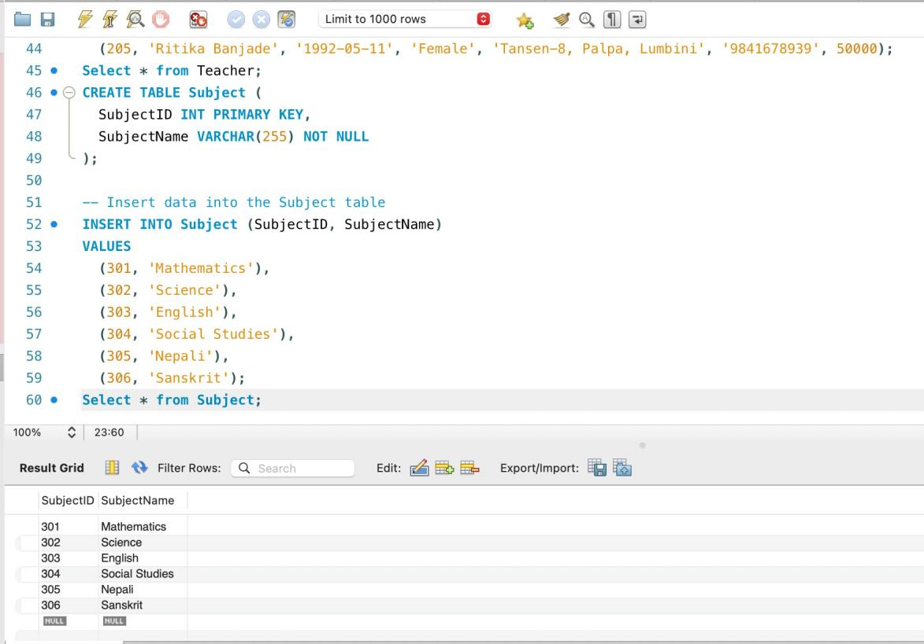

**Figure 14:**

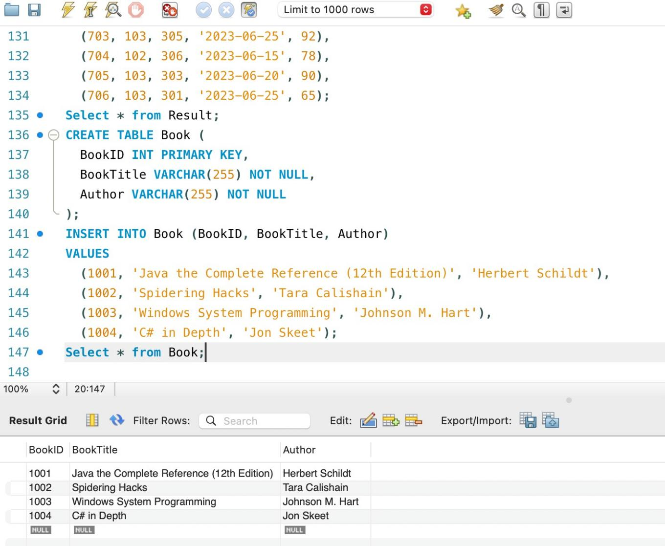

**Figure 15:**

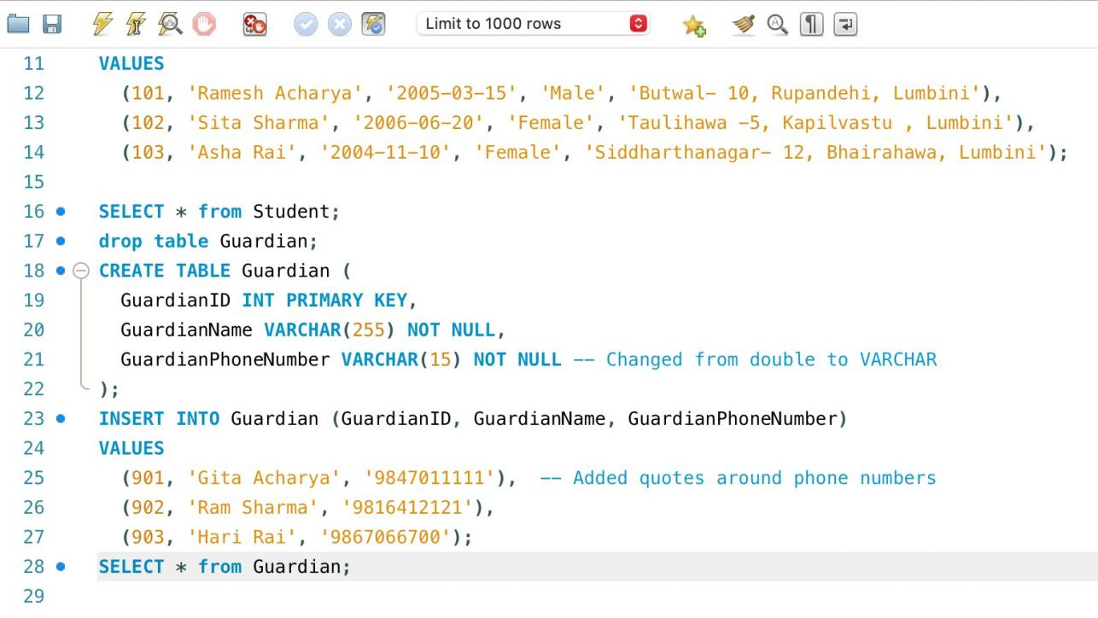

**Figure 16:**

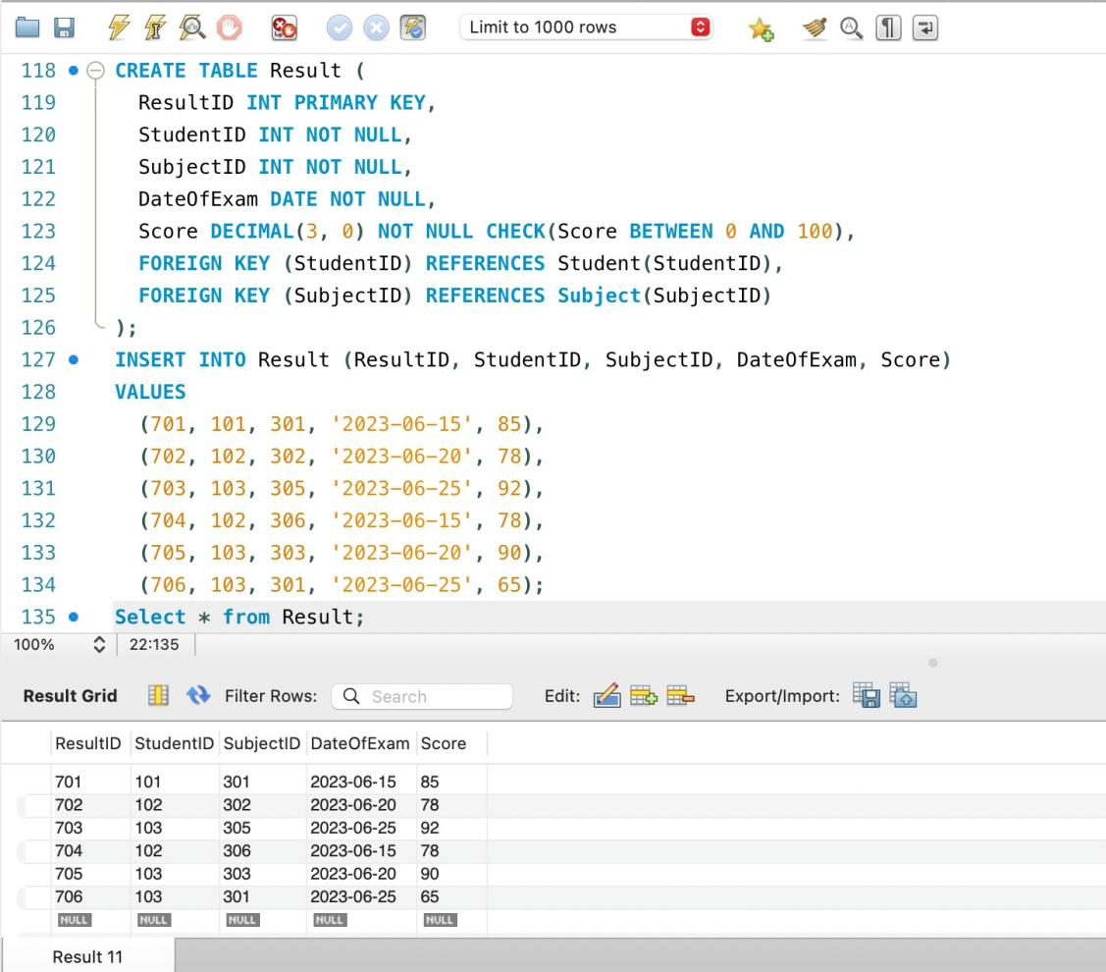

**Figure 17**

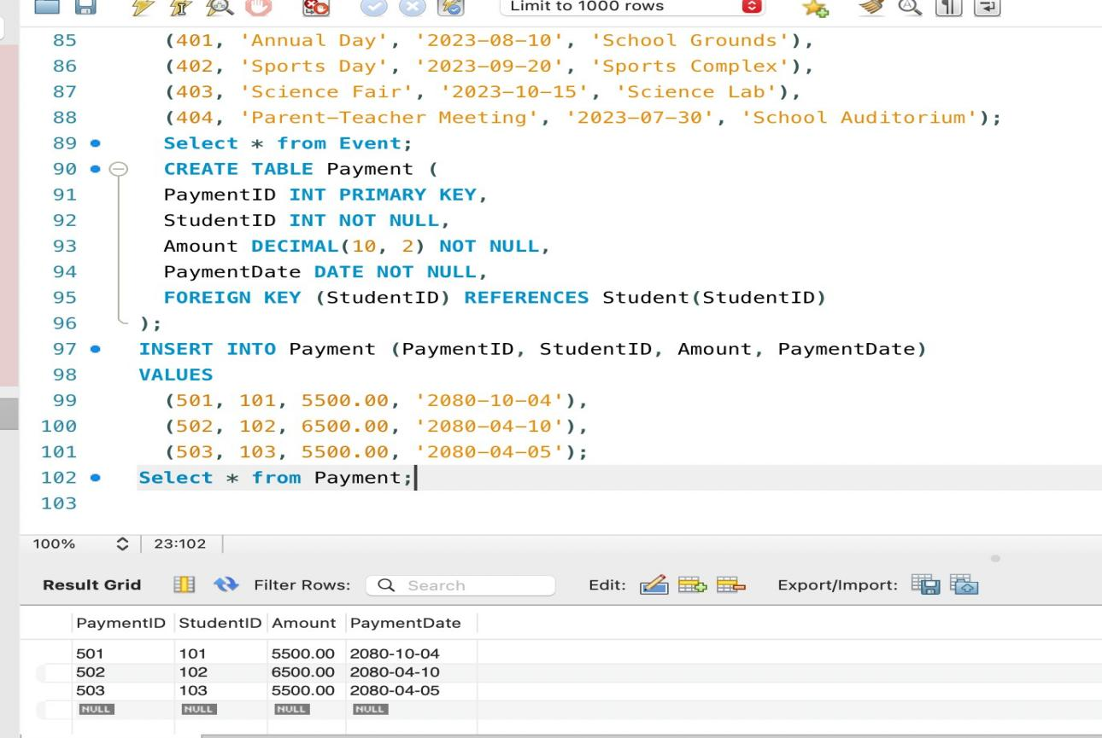

**Figure 18:**

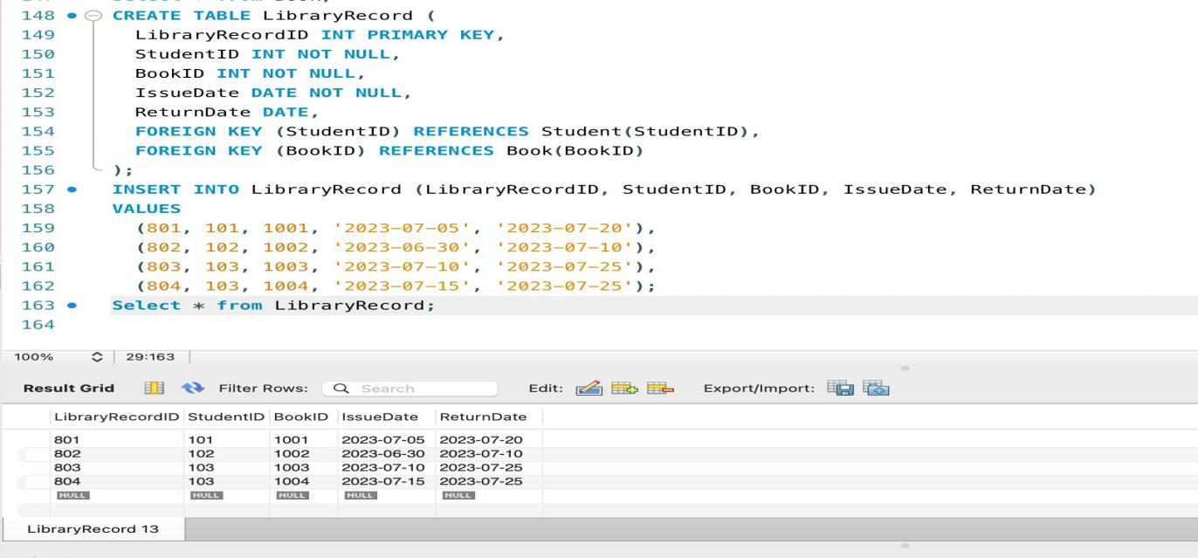

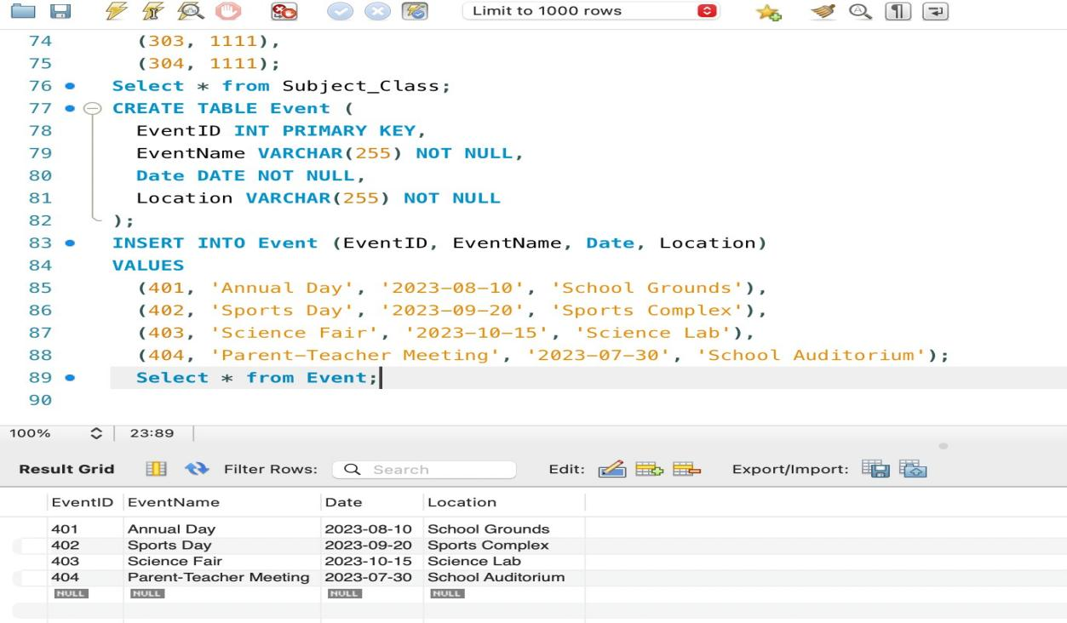

**Figure 19:**

**Figure 20:**

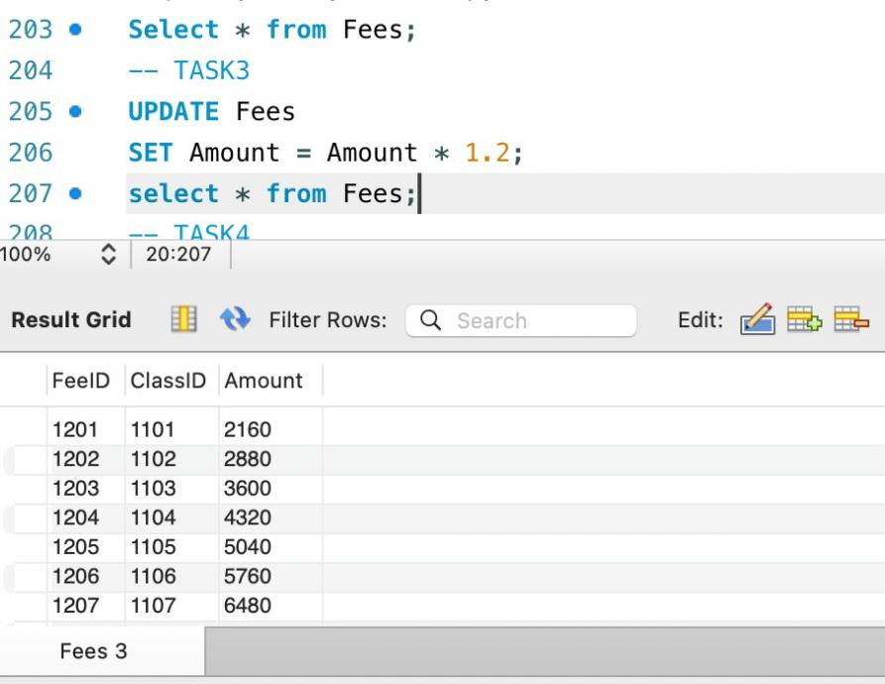

**Figure 21:**

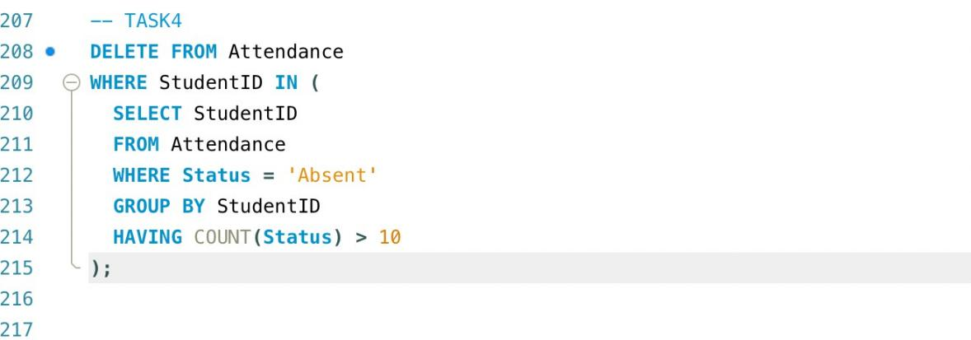

**Figure 22:**

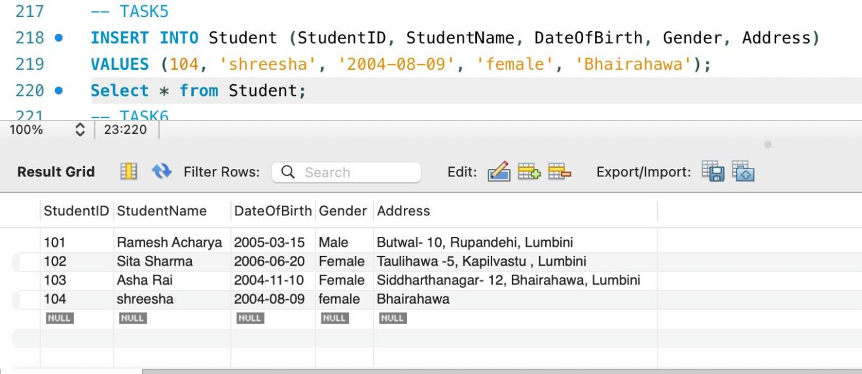

**Figure 24:**

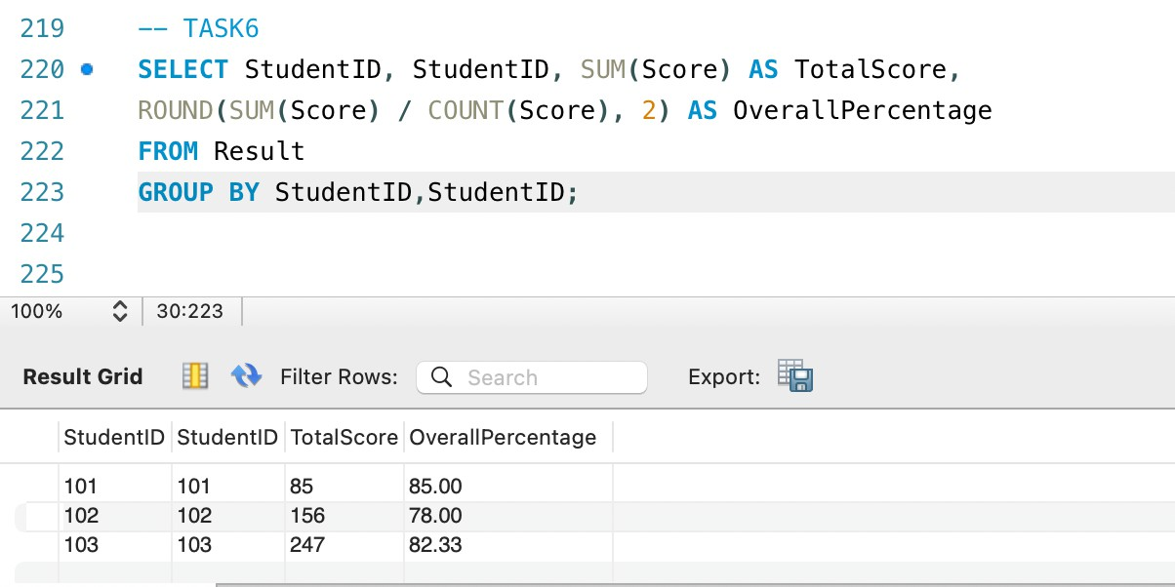

**Figure 23:**

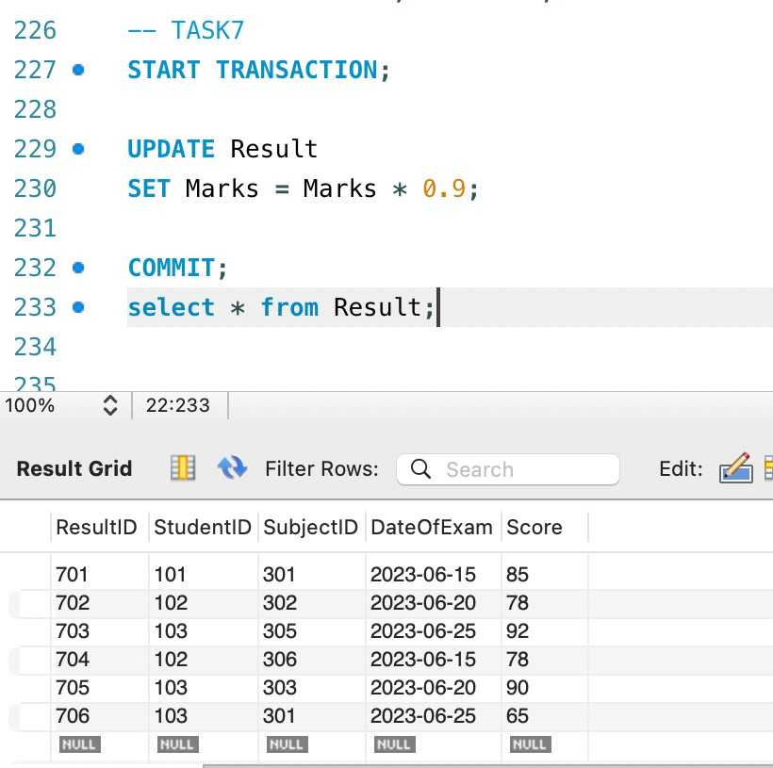

# Data Visualization

It refers to visual displays of information communicate complex data relationships and data-driven insights in a way that is easy to understand.

**Figure 25:**

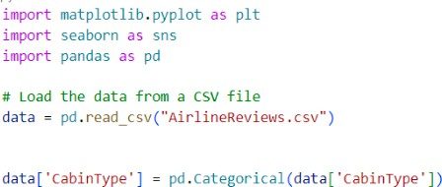

**Figure 26:**

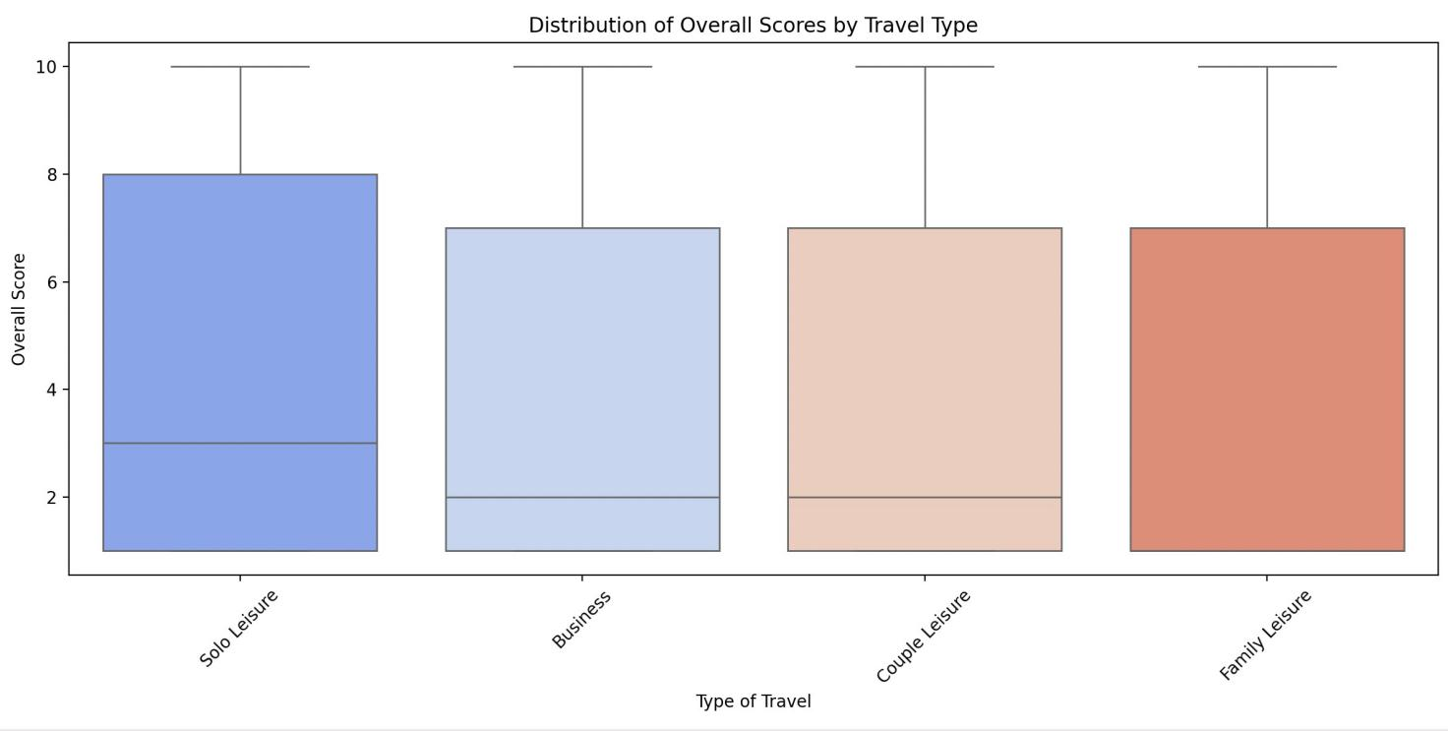



**Figure 27:**

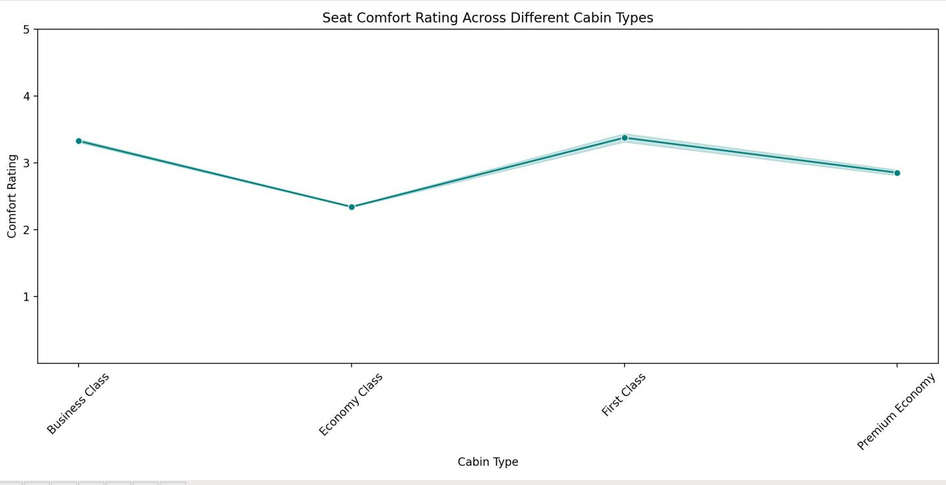

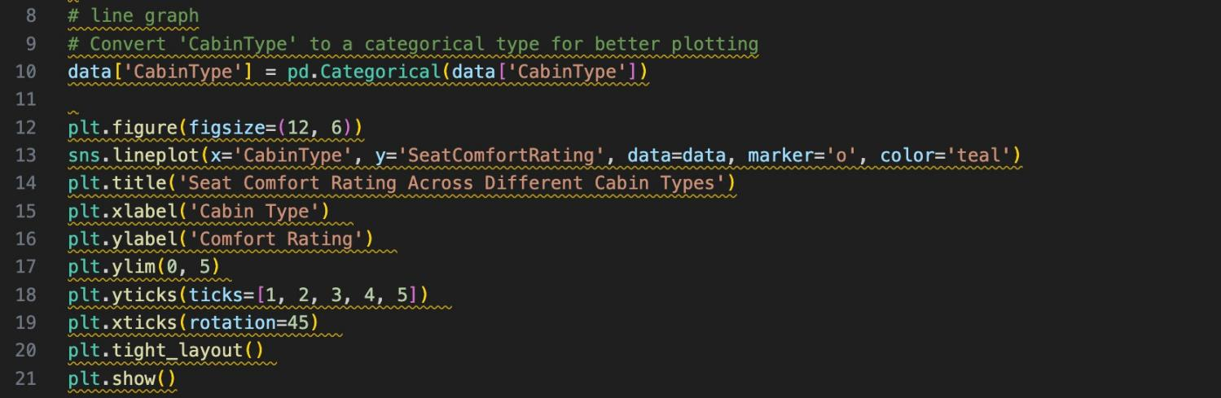

**Figure 28:**

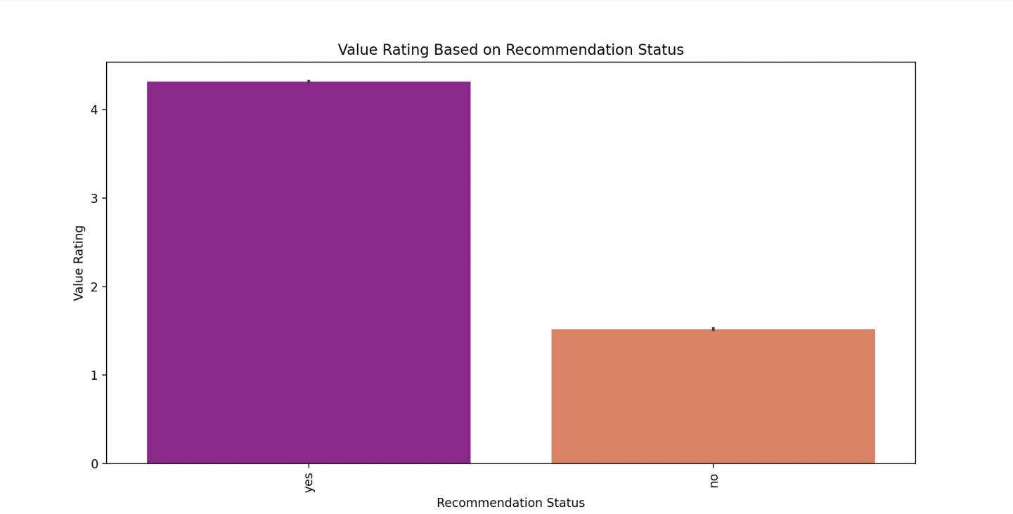

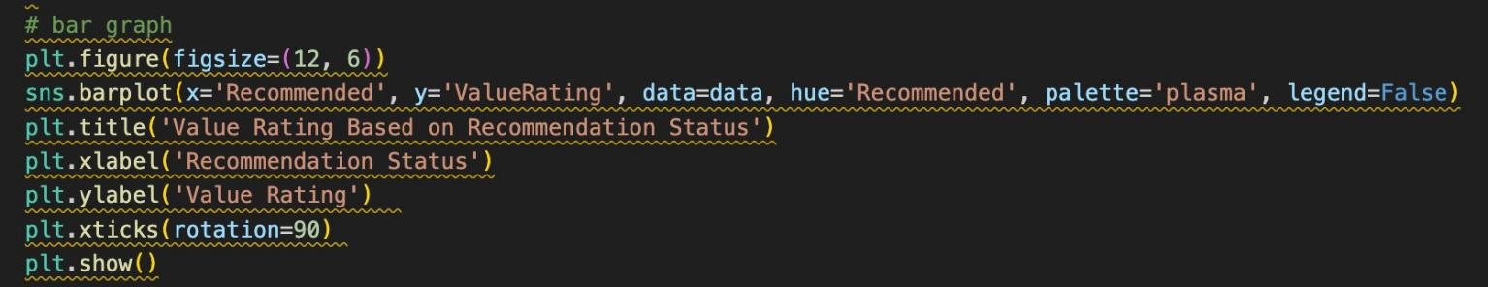

**Figure 29:**

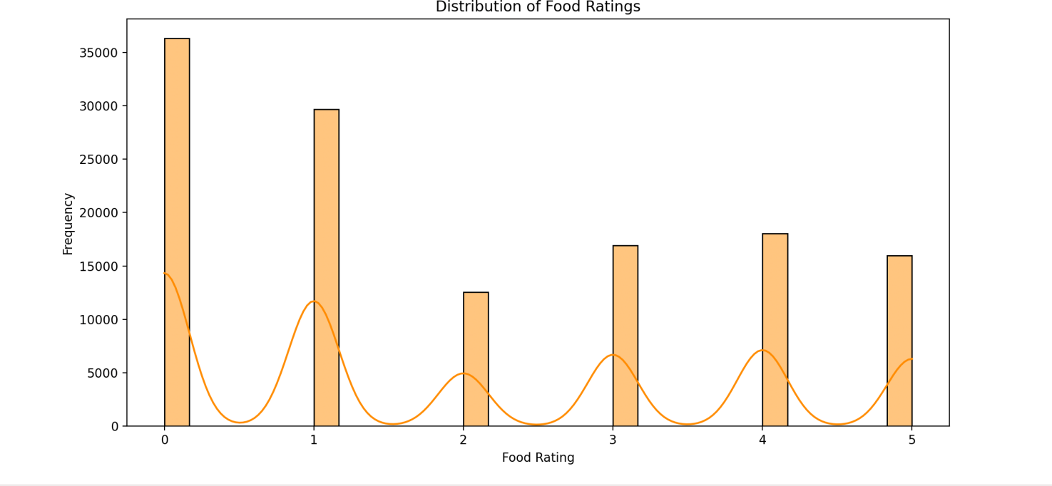

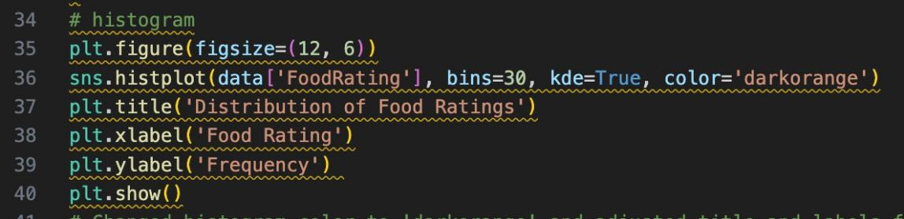

**Figure 30:**

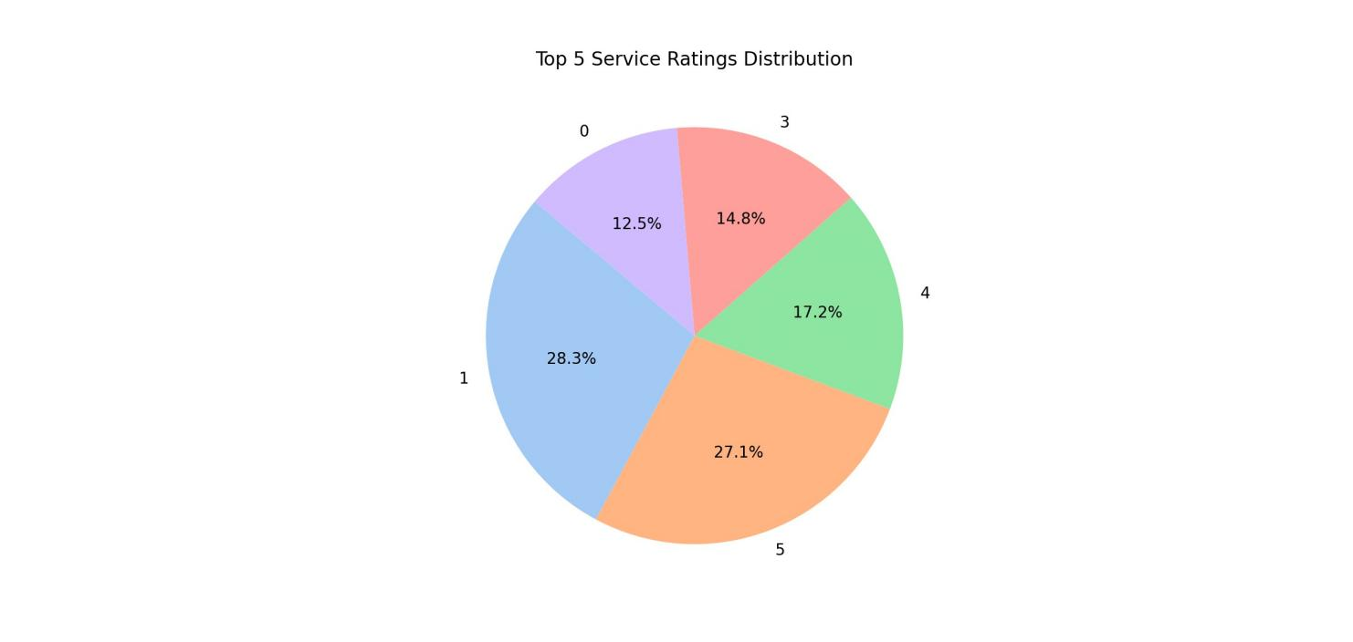

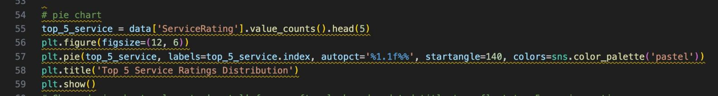

# Conclusion

Through the course of this project, I gained valuable skills in data visualization, advanced data normalization, crafting SQL queries, and developing ER diagrams. I am grateful for the guidance of Mr. Ayush Kaji Dangol, my module leader, which was instrumental in the completion of this project. This experience has significantly strengthened my abilities in data analysis, SQL, and data modeling, which will be advantageous for my future endeavors.

# Reference